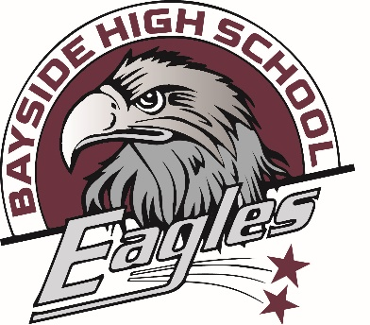 | BAYSIDE HIGH SCHOOL  14405 49th Street North  Clearwater, Florida 33762  727-507-4730/Fax 507-4735  www.pinellas.k12.fl.us  Konrad McCree, Principal  Megan Marshall, Assistant Principal

What is Title I

Title I is a federally funded program designed to address the academic needs of students and to assist them in meeting the state’s high standards, particularly in the areas of reading, writing, science and mathematics. The Pinellas County School District receives funds based upon the number of students who are eligible for free or reduced-price lunch.

What is a Title I School?

Title I schools are determined by the percentage of students at each school who are eligible for free or reduced lunch.

